Build and modernize AI Apps on Azure
95 Hr 7 Min Remaining
Instructions Resources Help 100%

Lab 06 - .NET - Dev - Deploying Azure Cosmos DB service for an app to store and access data
Estimated Duration: 30 minutes
Lab Type: Instructor Led
Objective In this lab, you will learn how to deploy an Azure Cosmos DB for an application to store and retrieve the data from it.

Exercise 1: Create a Cosmos DB account in azure
- Login to Azure portal at https://portal.azure.com
- Type in Azure Cosmos DB in the search bar and select Azure Cosmos DB.
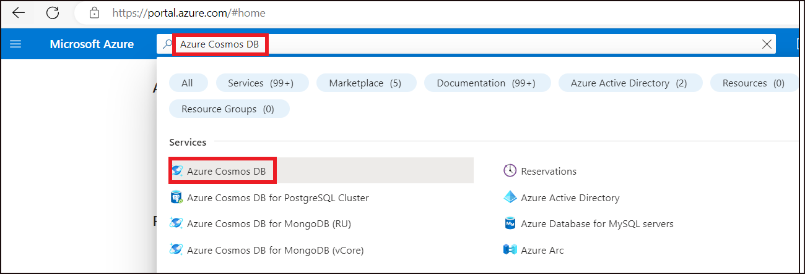
- On the Azure Cosmos DB page, click on + Create.
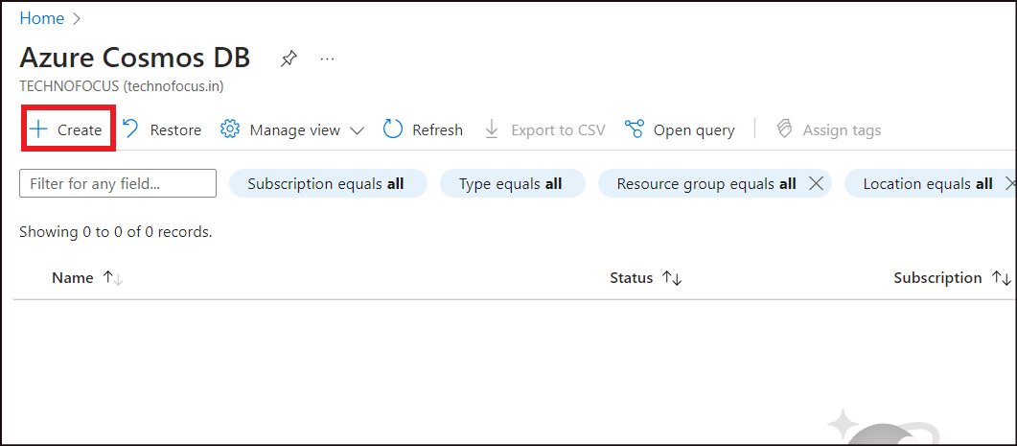
- On the Create an Azure Cosmos DB account page, click on Create under Azure Cosmos DB for NoSQL option.
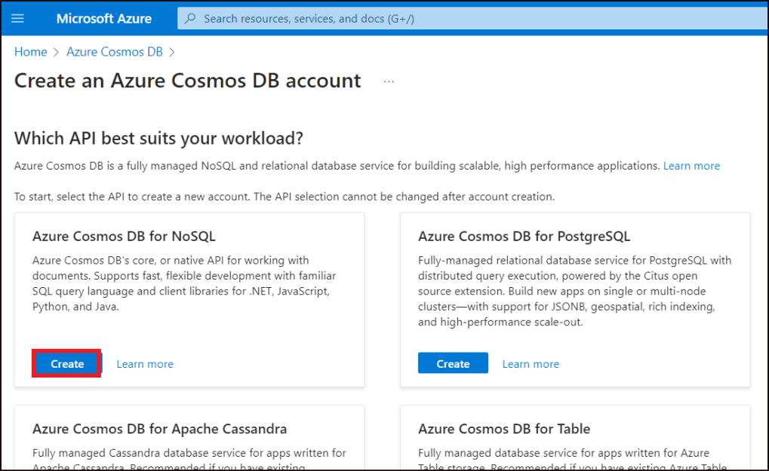
- Fill in the below details.
Property | Value
Subscription | Select your subscription
Resource Group | Create New -> Type in RGForCosmosDB Click OK.
Account name | azurecosdb-98 ( Replace 98 with a random number to ensure uniqueness)
Capacity mode | Provisioned throughput
Apply free tier license | Apply
- Click on Review + create.
- 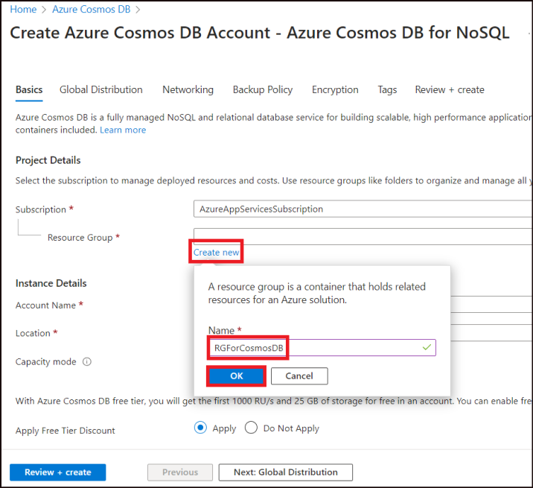
- 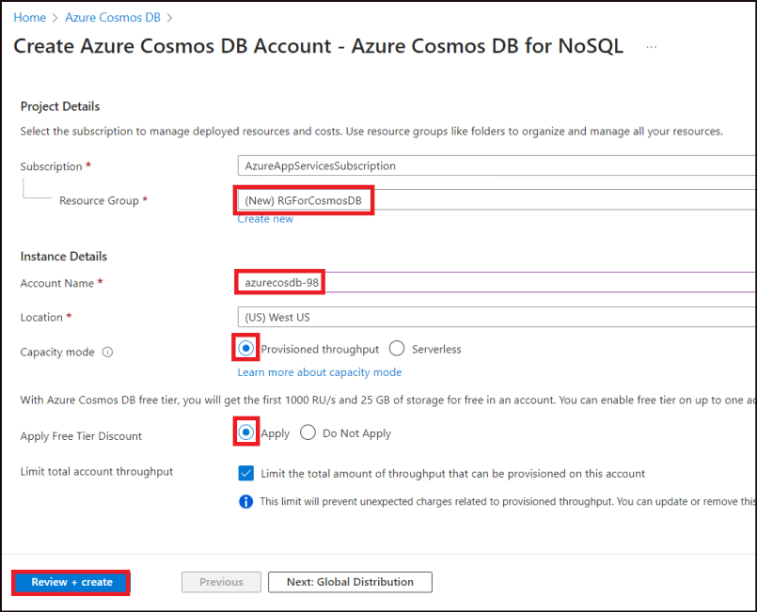
- Once the validation is successful, click on Create.
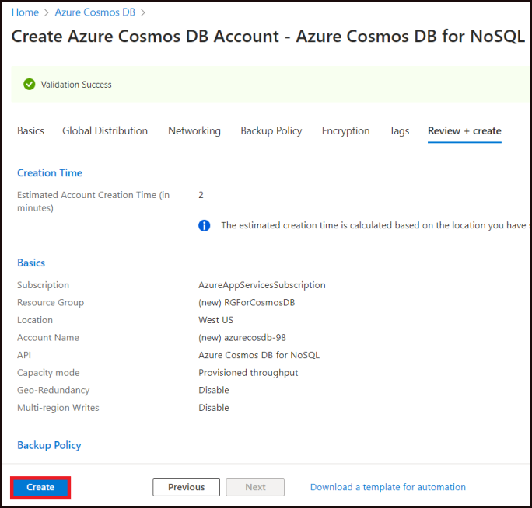
- Once the resource is created, a success message appears. Click on Go to resource.
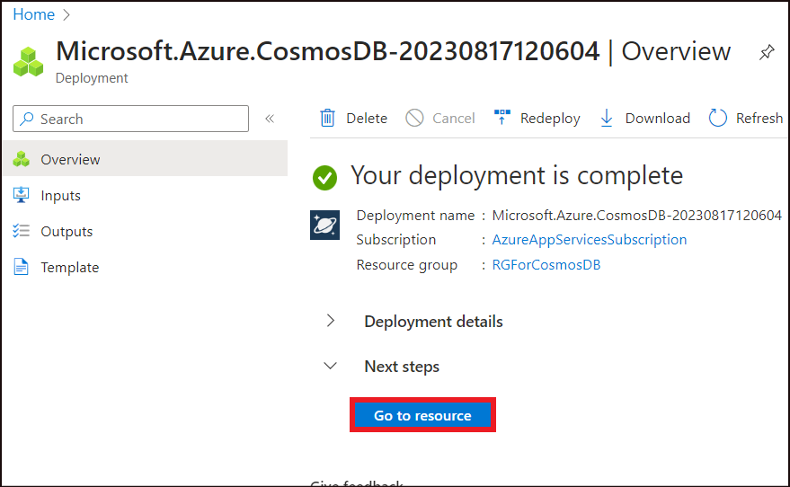
- Click on Keys from the left pane and make a note of the URI and the Primary Key from the page. These will be used in the later steps.
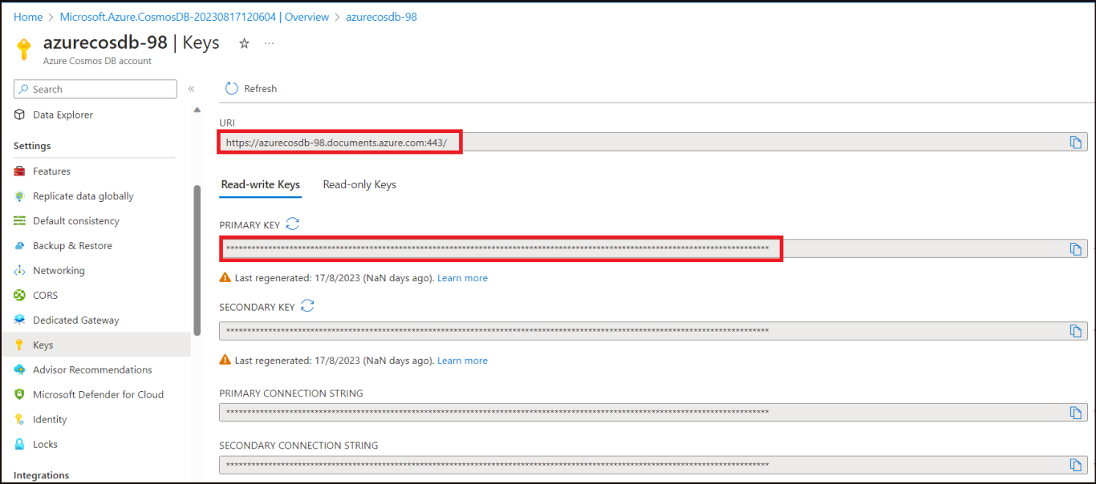

Exercise 2: Build the .NET SDK Project
- From the Start menu, select Visual Studio 2022.
- Click on Open a local folder.
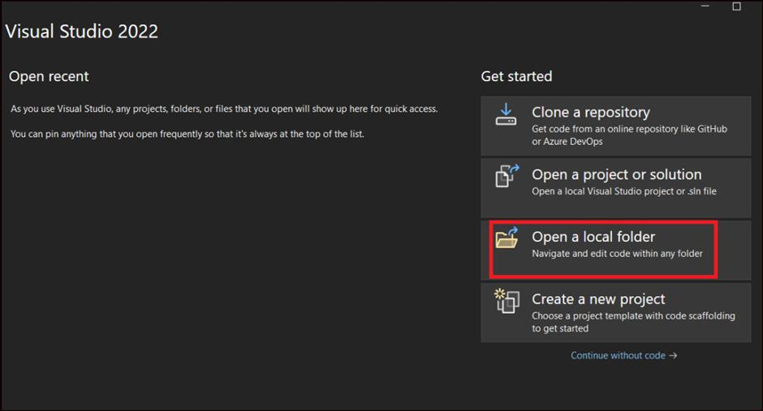
- Click on the cosmos-dotnet project from under C:\Lab files and click on Select Folder.
- From the Visual studio Solution Explorer, double click on CosmosGettingStarted.sln
Note: If the Solution Explorer does not get opened automatically, select Solution Explorer from View option.
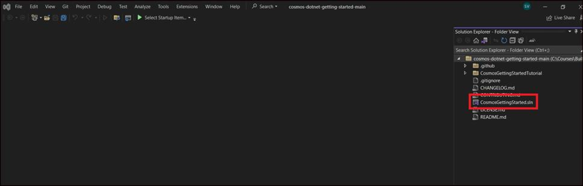
- Click on Build -> Build Solution.
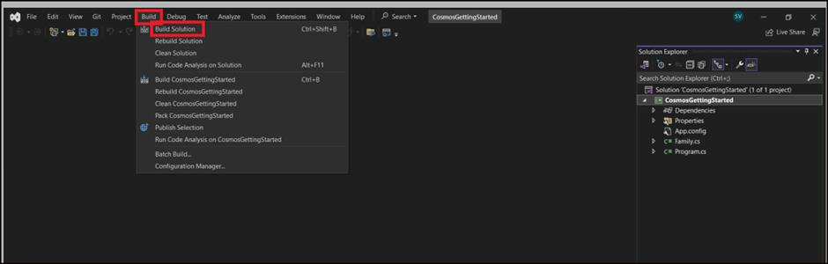
- The build should be successful.
- Open the file App.config from under the solution . Replace the URI and the Primary keys with the values that we noted down after creating the Azure cosmos DB and Save it .
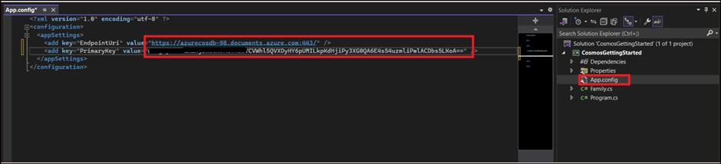
- Open the file Program.cs. Comment out the lines 70 and 71 where the Delete methods are being called and save the file.
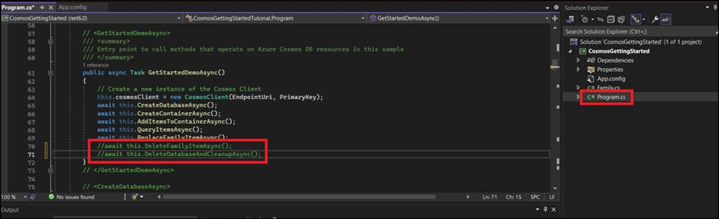

Exercise 3: Creating a Partitioned Container with .NET SDK

Task 1: Create CosmosClient Instance
The CosmosClient class is the main "entry point" to using the Core (SQL) API in Azure Cosmos DB. We are going to create an instance of the CosmosClient class by passing in connection metadata as parameters of the class' constructor. We will then use this class instance throughout the lab.
- Within the Program.cs editor tab, the EndpointUri holds the URI value of Azure Cosmos DB account and the PrimaryKey holds the PK value of your Azure Cosmos DB account.
// The Azure Cosmos DB endpoint for running this sample.
private static readonly string EndpointUri = ConfigurationManager.AppSettings["EndPointUri"];
// The primary key for the Azure Cosmos account.
private static readonly string PrimaryKey = ConfigurationManager.AppSettings["PrimaryKey"];

Task 2: Create Database and Container using the SDK:
- The below code will check to see if a database exists in your Azure Cosmos DB account with the passed in name(FamilyDatabase). If a database that matches does not exist, it will create a new database and return it.
private async Task CreateDatabaseAsync()
{
// Create a new database
this.database = await this.cosmosClient.CreateDatabaseIfNotExistsAsync(databaseId);
Console.WriteLine("Created Database: {0}\n", this.database.Id);
}

Task 3: Create a Partitioned Container using the SDK
To create a container, you must specify a name and a partition key path. A partition key is a logical hint for distributing data onto a scaled out underlying set of physical partitions and for efficiently routing queries to the appropriate underlying partition.
- This code will check to see if a container exists in your database that meets all of the specified parameters. If a container that matches does not exist, it will create a new container with the LastName as the partition key.
private async Task CreateContainerAsync()
{
// Create a new container
this.container = await this.database.CreateContainerIfNotExistsAsync(containerId, "/LastName");
Console.WriteLine("Created Container: {0}\n", this.container.Id); }
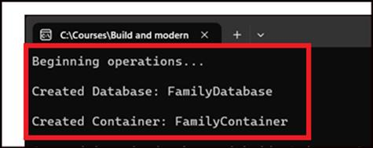

Task 4: Populate a Container with Items using the SDK
You will now use the .NET SDK to populate your container with two items for example purpose.
- The below code adds an entry into the FamilyContainer.
- // Create a family object for the Andersen family
- Family andersenFamily = new Family
- {
- Id = "Andersen.1",
- LastName = "Andersen",
- Parents = new Parent[]
- {
- new Parent { FirstName = "Thomas" },
- new Parent { FirstName = "Mary Kay" }
- },
- Children = new Child[]
- {
- new Child
- {
- FirstName = "Henriette Thaulow",
- Gender = "female",
- Grade = 5,
- Pets = new Pet[]
- {
- new Pet { GivenName = "Fluffy" }
- }
- }
- },
- Address = new Address { State = "WA", County = "King", City = "Seattle" },
- IsRegistered = false
- };

- try
- {
- // Read the item to see if it exists.
- ItemResponse<Family> andersenFamilyResponse = await this.container.ReadItemAsync<Family>(andersenFamily.Id, new PartitionKey(andersenFamily.LastName));
- Console.WriteLine("Item in database with id: {0} already exists\n", andersenFamilyResponse.Resource.Id);
- }
- catch(CosmosException ex) when (ex.StatusCode == HttpStatusCode.NotFound)
- {
- // Create an item in the container representing the Andersen family. Note we provide the value of the partition key for this item, which is "Andersen"
ItemResponse<Family> andersenFamilyResponse = await this.container.CreateItemAsync<Family>(andersenFamily, new PartitionKey(andersenFamily.LastName));
// Note that after creating the item, we can access the body of the item with the Resource property off the ItemResponse. We can also access the RequestCharge property to see the amount of RUs consumed on this request.
Console.WriteLine("Created item in database with id: {0} Operation consumed {1} RUs.\n", andersenFamilyResponse.Resource.Id, andersenFamilyResponse.RequestCharge);
}
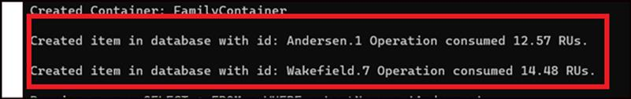

Task 5: Query Data using the SDK
- The below code queries the Database with the partition key(Last name as 'Anderson').
- The code uses the FeedResponse class to receive the accessed item, iterate it and output the result.
- private async Task QueryItemsAsync()
- {
- var sqlQueryText = "SELECT * FROM c WHERE c.LastName = 'Andersen'";

- Console.WriteLine("Running query: {0}\n", sqlQueryText);

- QueryDefinition queryDefinition = new QueryDefinition(sqlQueryText);
- using FeedIterator<Family> queryResultSetIterator = this.container.GetItemQueryIterator<Family>(queryDefinition);

- List<Family> families = new List<Family>();

- while (queryResultSetIterator.HasMoreResults)
- {
- FeedResponse<Family> currentResultSet = await queryResultSetIterator.ReadNextAsync();
- foreach (Family family in currentResultSet)
- {
- families.Add(family);
- Console.WriteLine("\tRead {0}\n", family);
- }
- }
}
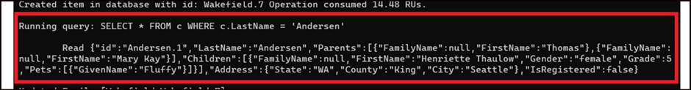

Task 6: Update Data using the SDK
- This part of the code updates the data in the Family Container.
- private async Task ReplaceFamilyItemAsync()
- {
- ItemResponse<Family> wakefieldFamilyResponse = await this.container.ReadItemAsync<Family>("Wakefield.7", new PartitionKey("Wakefield"));
- var itemBody = wakefieldFamilyResponse.Resource;

- // update registration status from false to true
- itemBody.IsRegistered = true;
- // update grade of child
- itemBody.Children[0].Grade = 6;

- // replace the item with the updated content
- wakefieldFamilyResponse = await this.container.ReplaceItemAsync<Family>(itemBody, itemBody.Id, new PartitionKey(itemBody.LastName));
- Console.WriteLine("Updated Family [{0},{1}].\n \tBody is now: {2}\n", itemBody.LastName, itemBody.Id, wakefieldFamilyResponse.Resource);
}
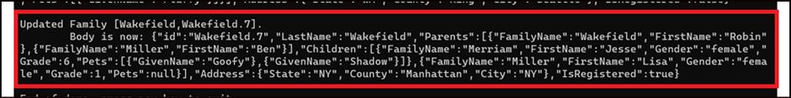

Task 7: Delete Data using the SDK
- This part of the code deletes all the created data.
- private async Task DeleteFamilyItemAsync()
- {
- var partitionKeyValue = "Wakefield";
- var familyId = "Wakefield.7";

- // Delete an item. Note we must provide the partition key value and id of the item to delete
- ItemResponse<Family> wakefieldFamilyResponse = await this.container.DeleteItemAsync<Family>(familyId,new PartitionKey(partitionKeyValue));
- Console.WriteLine("Deleted Family [{0},{1}]\n", partitionKeyValue, familyId);
}
- Since we have commented out the part to invoke the Delete method, the data will persist in the Cosmos DB.
- To check deletion, delete the database and container from Azure, uncomment the deletion invocation from the code and execute again.

Exercise 4: Execute the project
- From the Visual Studio, select Debug -> Start without debugging.
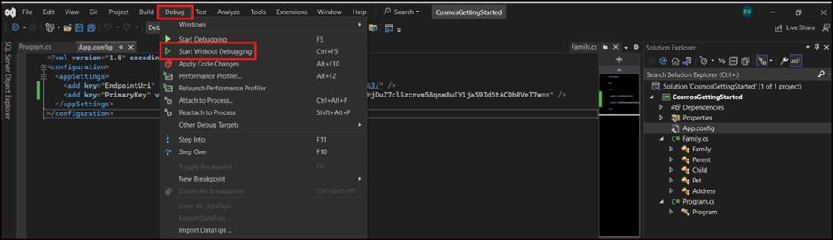
- The application starts and creates the Database, Container and insert data into the container. It also updates the entry into the container.
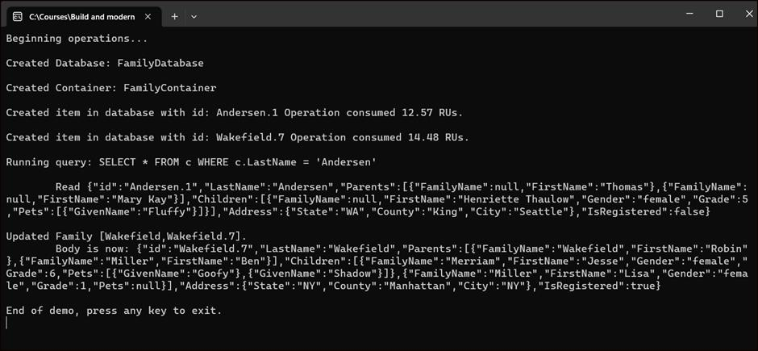

Exercise 5: Checking the DB updates in the Azure portal
- Back in the Azure portal Cosmos DB Overview page, from the left pane select Data Explorer and then select the FamilyDatabase.
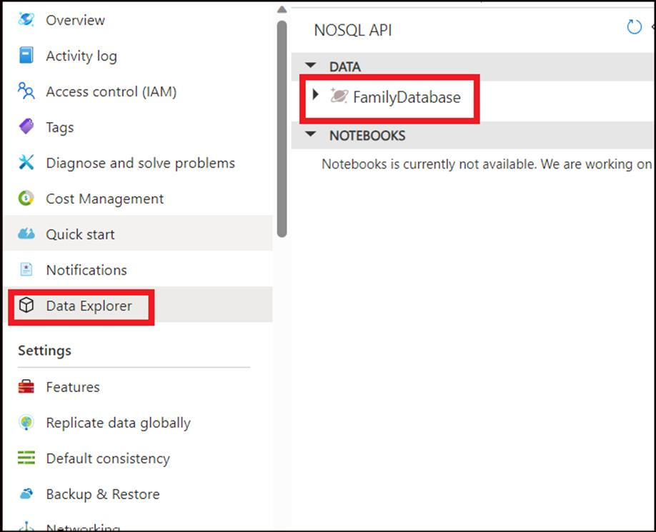
- You will find 2 entries under the FamilyContainer.
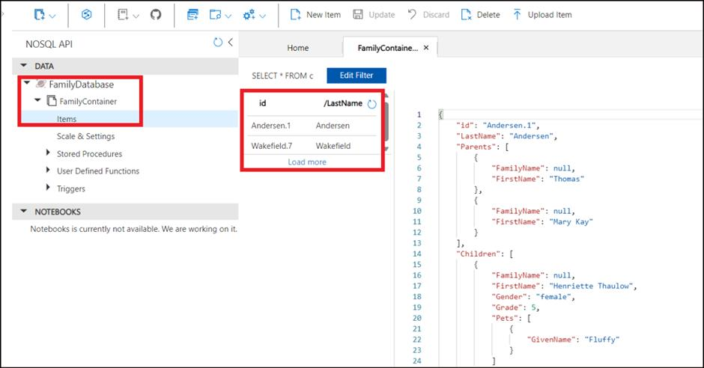

Exercise 6: Indexing in Azure Cosmos DB
In this exercise, you will modify the indexing policy of the Azure Cosmos DB container(Family Container).
- Still in the FamilyContainer page in Azure portal, select Scale & Settings and click on the Indexing Policy tab.
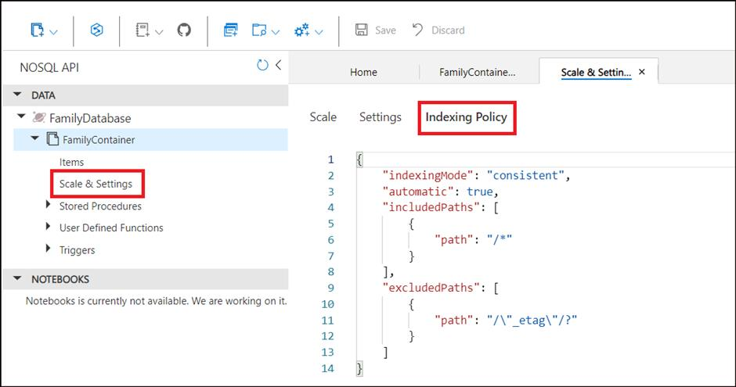
- This is the Indexing Policy that gets created by default.
- An Indexing policy can be modified through Azure portal, any Azure Cosmos DB SDK as well as ARM template, PowerShell or Azure CLI
- Here, we will modify the indexing policy through the Azure Portal.

Task 1: Understand query requirements
Before modifying indexing policy, it\'s important to understand how the data is used in the collection.
- Consider the below query.
SELECT * FROM c where c.Address.State = "WA"
This query only require an index be defined on Address.State. We can modify the indexing policy to index only these properties.

Task 2: Edit the indexing policy by including paths
- In the Azure Portal, in the Indexing Policy section of FamilyContainer, replace the existing json file with the following:
- {
- "indexingMode": "consistent",
- "automatic": true,
- "includedPaths": [
- {
- "path": "/Address/*"
- }
- ],
- "excludedPaths": [
- {
- "path": "/*"
- }
- ]
}
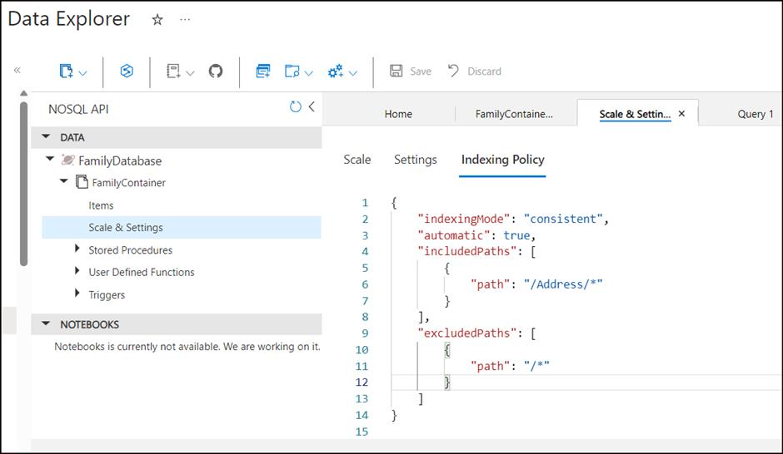
- This new indexing policy will create an index on only the Address. It will remove indexes on all other properties.
- Click on Save.
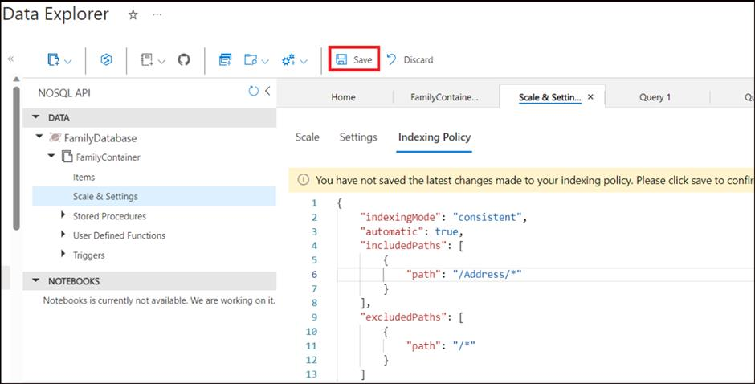
- In the menu, select the New SQL Query icon.
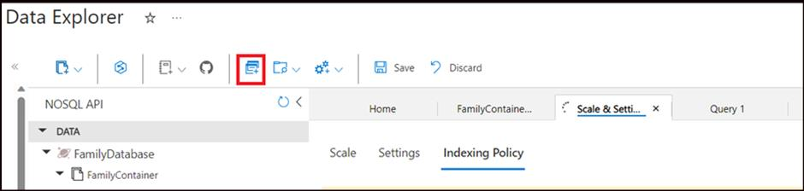
- Paste the following SQL query and select Execute Query:
SELECT * FROM c where c.Address.State = "WA"
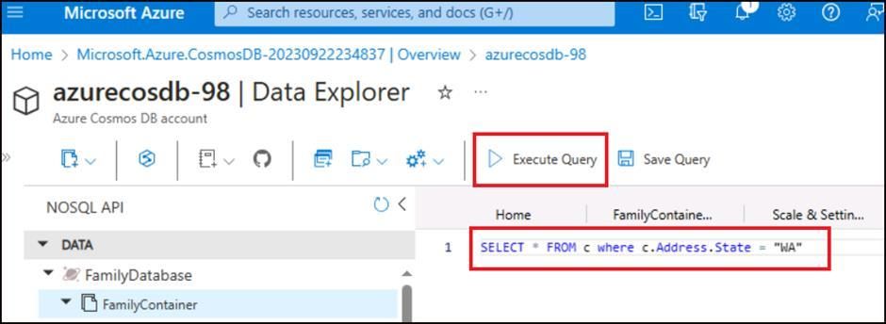
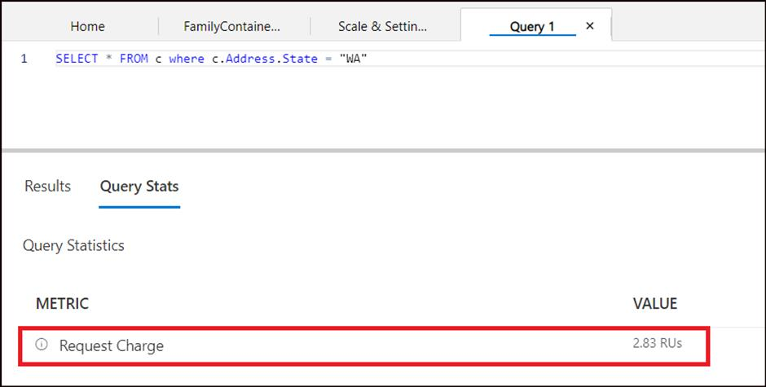

Exercise 7: Clean up resources
- Select the RGForCosmosDB Resource group from the Azure portal and click on Delete resource group.
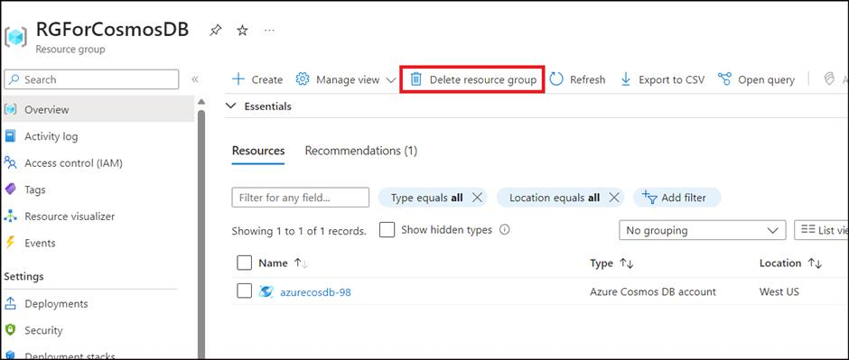
- Type in RGForCosmosDB in the Enter resource group name and then click on Delete.
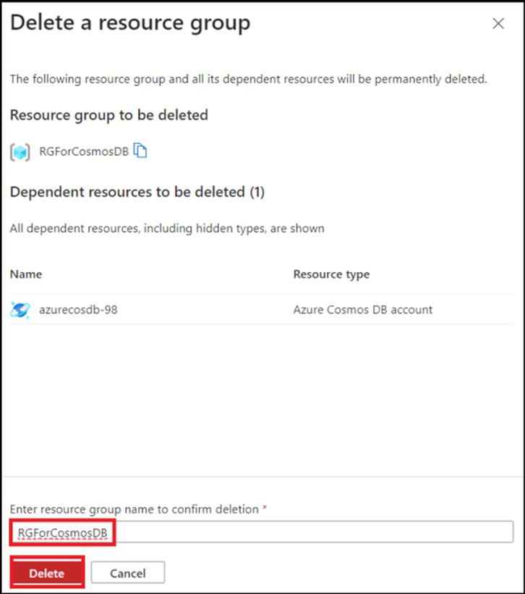
- Click Delete on the Delete confirmation box.
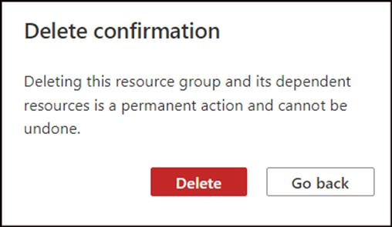
- A success notification is obtained once the deletion is done.
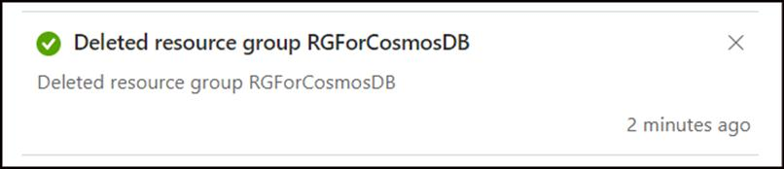
Summary
In this lab, you have learnt how to deploy an Azure Cosmos DB and work with it.

